# DP500: Create a star schema model

## Overview

The estimated time to complete the lab is 30 minutes

In this lab, you will use Power BI Desktop to develop a data model over the Azure Synapse Adventure Works data warehouse. The data model will allow you to publish a semantic layer over the data warehouse.

In this lab, you learn how to:

* Create a Power BI connection to an Azure Synapse Analytics SQL pool.
* Develop model queries.
* Organize the model diagram.

## Get started

In this exercise, prepare your environment.

### Set up Power BI Desktop

In this task, you will set up Power BI Desktop.

1. To open Power BI Desktop, on the taskbar, select the Power BI Desktop shortcut.

1. Select X located at the top-right of the getting started window.



1. At the top-right corner of Power BI Desktop, if you’re not already signed in, select Sign In. Use the lab credentials to complete the sign in process.

1. Close Power BI Desktop.

You will open Power BI Desktop again in the next exercise.

### Start the SQL pool

In this task, you will start the SQL pool.

1. In a web browser, go to <https://portal.azure.com>.
2. Use the lab credentials to complete the sign in process.
3. Locate the SQL pool.
4. Resume the SQL pool.

TODO: Provide an image

Important: The SQL pool is a costly resource. Please limit the use of this resource when working on this lab. The final task in this lab will instruct you to pause the resource.

## Develop a data model

In this exercise, you will develop a DirectQuery model to support Power BI analysis and reporting of the data warehouse reseller sales subject.

### Download a dataset file

In this task, you will download a Power BI data source file from Synapse Studio.

1. In a web browser, navigate to Synapse Studio.
2. At the left, select the Develop hub.

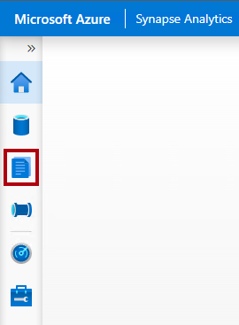

1. In the Develop pane, expand Power BI, then expand the workspace, and then select Power BI datasets.

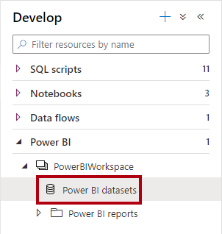

1. In the Power BI Datasets pane, select New Power BI Dataset.

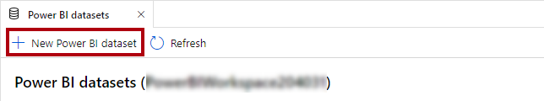

1. In the left pane, at the bottom, select Start.



1. Select your SQL pool, possibly named SQLPool01, and then select Continue.



1. To download the .pbids file, select Download.



A .pbids file contains a connection to your SQL pool. It’s a convenient way to start your project. When opened, it will create a new Power BI Desktop solution that already stores the connection details to your SQL pool.

1. When the .pbids file has downloaded, open it.

When the file opens, it will prompt you to create queries using the connection. You will define those queries in the next task.

### Create model queries

In this task, you will create five Power Query queries that will each load as a table to your model.

1. In Power BI Desktop, in the SQL Server Database window, at the left, select Microsoft Account.

1. Select Sign In.
2. Sign in using the lab Azure credentials.
3. Select Connect.

1. In the Navigator window, select (don’t check) the DimDate table.
2. In the right pane, notice the preview result, which shows a subset of the table rows.

1. To create queries (which will become model tables), check the following five tables:

* DimDate
* DimProduct
* DimReseller
* DimSalesTerritory
* FactResellerSales

1. To apply transformations to the queries, at the bottom-right, select Transform Data.



Transforming the data allows you to define what data will be available in your model.

1. In the Connection Settings window, select the DirectQuery option.

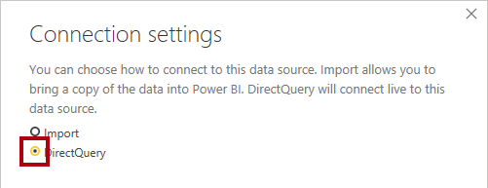

This decision is important. DirectQuery is a storage mode. A model table that uses DirectQuery storage mode doesn’t store data. So, when a Power BI report visual queries a DirectQuery table, Power BI sends a native query to the data source. This storage mode can be used for large data stores like Azure Synapse Analytics (because it could be impractical or uneconomic to import large data volumes) or when near real-time results are required.

1. Select OK.

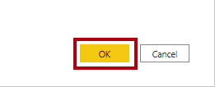

1. In the Power Query Editor window, in the Queries pane (located at the left), notice there is one query for each table you checked.

You will now revise the definition of each query. Each query will become a model table when it’s applied to the model. You will now rename the queries, so they’re described in more friendly and concise ways, and apply transformations to deliver the columns required by the known reporting requirements.

1. Select the DimDate query.

1. In the Query Settings pane (located at the right), to rename the query, in the Name box, replace the text with Date, and then press Enter.

1. To remove unnecessary columns, on the Home ribbon tab, from inside the Manage Columns group, select the Choose Columns icon.

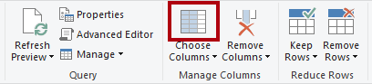

1. In the Choose Columns window, to uncheck all checkboxes, uncheck the first checkbox.

1. Check the following five columns.

* DateKey
* FullDateAlternateKey
* EnglishMonthName
* FiscalQuarter
* FiscalYear

This selection of columns determine what will be available in your model.

1. Select OK.



1. In the Query Settings pane, in the Applied Steps list, notice that a step was added to remove other columns.

Power Query defines steps to achieve the desired structure and data. Each transformation is a step in the query logic.

1. To rename the FullDateAlternateKey column, double-click the FullDateAlternateKey column header.
2. Replace the text with Date, and then press Enter.

1. Notice that a new applied step is added to the query.

1. Rename the following columns:

* EnglishMonthName as Month
* FiscalQuarter as Quarter
* FiscalYear as Year

1. To validate the query design, in the status bar (located along the bottom of the window), verify that the query has five columns.



Important: If the query design does not match, review the exercise steps to make any corrections.

The design of the Date query is now complete.

1. In the Applied Steps pane, right-click the last step, and then select View Native Query.

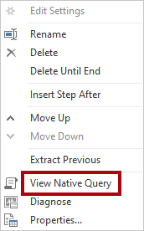

1. In the Native Query window, review the SELECT statement that reflects the query design.

This concept is important. A native query is what Power BI uses to query the data source. To ensure best performance, the database developer should ensure this query is optimized by creating appropriate indexes, etc.

1. To close the Native Query window, select OK.



1. Select the DimProduct query.

1. Rename the query as Product.

1. To filter the query, in the FinishedGoodsFlag column header, open the dropdown menu, uncheck FALSE.

1. Select OK.
2. Remove all columns, except:

* ProductKey
* EnglishProductName
* Color
* DimProductSubcategory

1. To configure the query to join tables, in the DimProductSubcategory column header, select the Expand button, and then uncheck (Select all columns).

This feature allows joining tables based on foreign key constraints in the source data. The design approach taken by this lab is to join snowflake dimension tables together to produce a denormalized representation of the data.

1. Uncheck the Use original column name as prefix.

1. Check the following two columns:

* EnglishProductSubcategoryName
* DimProductCategory

1. Select OK.
2. Repeat the previous steps to expand the DimProductCategory and introduce the EnglishProductCategoryName column.
3. Rename the following columns:

* EnglishProductName as Product
* EnglishProductSubcategoryName as Subcategory
* EnglishProductCategoryName as Category

1. In the Applied Steps pane, right-click the last step, and then select View Native Query.



1. In the Native Query window, review the SELECT statement that reflects the query design.

The statement includes nested subqueries to produce the denormalized query result.

1. To close the Native Query window, select OK.
2. Verify that the query has five columns.

The design of the Product query is now complete.

1. Select the DimReseller query.

1. Rename the query as Reseller.
2. Remove all columns, except:

* ResellerKey
* BusinessType
* ResellerName

1. Rename the following columns:

* BusinessType as Business Type (separate with a space)
* ResellerName as Reseller

1. Verify that the query has three columns.

The design of the Reseller query is now complete.

1. Select the DimSalesTerritory query.

1. Rename the query as Territory.
2. Remove all columns, except:

* SalesTerritoryKey
* SalesTerritoryRegion
* SalesTerritoryCountry
* SalesTerritoryGroup

1. Rename the following columns:

* SalesTerritoryRegion as Region
* SalesTerritoryCountry as Country
* SalesTerritoryGroup as Group

1. Verify that the query has four columns.

The design of the Territory query is now complete.

1. Select the FactResellerSales query.

1. Rename the query as Sales.
2. Remove all columns, except:

* ResellerKey
* ProductKey
* OrderDateKey
* SalesTerritoryKey
* OrderQuantity
* UnitPrice

1. Rename the following columns:

* OrderQuantity as Quantity
* UnitPrice as Price

1. To add a calculated column, on the Add Column ribbon tab, from inside the General group, select Custom Column.

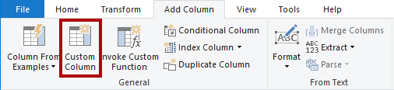

1. In the Custom Column window, in the New Column Name box, replace the text with Revenue.

1. In the Custom Column Formula box, enter the following formula:
   1. Power Query (M)
   2. [Quantity] * [Price]
2. Select OK.
3. To modify the column data type, in the Revenue column header, select ABC123, and then select Decimal Number.

1. Review the native query, noticing the Revenue column calculation logic.
2. Verify that the query has seven columns.

The design of the Sales query is now complete.

1. To apply the queries, on the Home ribbon tab, from inside the Close group, select the Close & Apply icon.

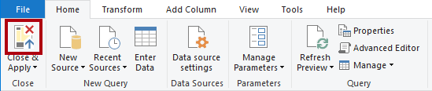

Each query is applied to create a model table. Because the data connection is using DirectQuery storage mode, only the model structure is created. No data is imported. The model now consists of one table for each query.

1. In Power BI Desktop, when the queries have been applied, at the bottom-left corner in the status bar, notice that the model storage mode is DirectQuery.



### Organize the model diagram

In this task, you will organize the model diagram to easily understand the star schema design.

1. In Power BI Desktop, at the left, select Model view.



1. To resize the model diagram to fit to screen, at the bottom-left, select the Fit to screen icon.



1. Drag the tables into position so that the Sales fact table is located at the middle of the diagram, and the remain tables, which are dimension tables, are located around the fact table.
2. If any of the dimension tables aren’t related to the fact table, use the following instructions to create a relationship:

* Drag the dimension key column (for example, ProductKey) and drop it on the corresponding column of the Sales table.
* In the Create Relationship window, select OK.

1. Review the final layout of the model diagram.

The creation of the star schema model is now complete. There are many modeling configurations that could now be applied, like adding hierarchies, calculations, and setting properties like column visibility.

1. Optionally, to save the solution, at the top-left, select the disk icon.
2. In the Save As window, go to the D:\DP500\Create a star schema model\Solution folder.
3. In the File name box, enter Sales Analysis.

1. Select Save.
2. Close Power BI Desktop.

### Stop the SQL pool

In this task, you will stop the SQL pool.

1. In a web browser, go to <https://portal.azure.com>.
2. Locate the SQL pool.
3. Stop the SQL pool.

TODO: Provide an image